**Index**

|  |  |  |
| --- | --- | --- |
| No # | Title |  |
|  | Automation Framework Structure   1. DataSet 2. LibraryPackage 3. MediaFiles 4. TestSuite |  |
|  | Rules and common standards for using framework. |  |

# Automation Framework Structure.

The framework is organized in following directory structure.

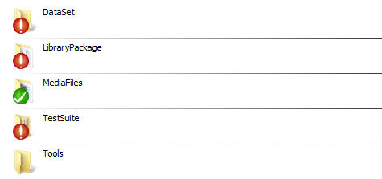

1. DataSet

This directory is being used to store configuration file and all the test case related data.

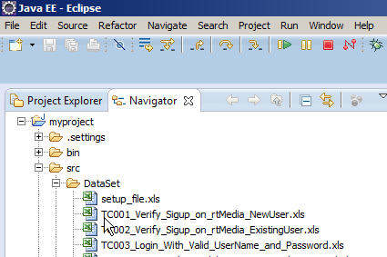

Configuration file is named as ***setup_file.xls*** and contains the set up configuration details like which browser to be used and what baseUrl to be used during test suite run.

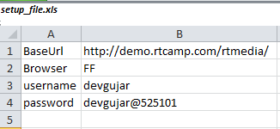

You can use the below code to access the test case data from excel sheets stored in DataSet structure

// Create Page Object  
rtmediaPageBrowser rtmediaPage = **new** rtmediaPageBrowser();  
  
//Get Test case Data

Hashtable<String, String> excellData = rtmediaPage.GetExcell_Data_As_Hashtable("TC003_Login_With_Valid_UserName_and_Password.xls");

excellData.get("username")

1. LibraryPackage

This directory is used to store all the functions which are required to perform actions in test cases.

Collection of common methods required for performing action and storing them in one place makes it easier to reuse the code across the test cases.

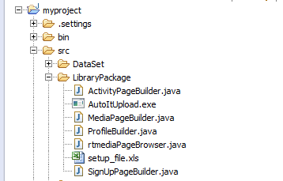

Example for using Page Classes.

// Create Page Object

rtmediaPageBrowser rtmediaPage = **new** rtmediaPageBrowser();

//Get Test data

Hashtable<String, String> excellData =

rtmediaPage.GetExcell_Data_As_Hashtable("TC001_Verify_Sigup_on_rtMedia_NewUser.xls");

//Start Home Page

rtmediaPage.Start_Home_Page();

SignUpPageBuilder SignUpPage = **new** SignUpPageBuilder();

SignUpPage.setUsername(excellData.get("signup_username"));  
. . . . .  
. . . . .

1. MediaFiles

This directory is used to store all the media files which are required to use in test cases

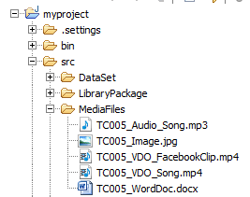

Example for using Media Files for upload.

**// Upload content on Media Page**

// Create Media Page Object

MediaPageBuilder MediaPage =**new** MediaPageBuilder();

// Navigate to Upload UI on Media Page

MediaPage.Navigate_to_UploadUI();

// Upload File with default settings for Album and Privacy

MediaPage.upload_File("TC005_Audio_Song.mp3");

**// Upload content on Activity page**

ActivityPageBuilder ActivityPage = **new** ActivityPageBuilder();

ActivityPage.Upload_File("TC005_Image.jpg");

1. TestSuite

This directory is used to store all the test script files which are required to use for execution.

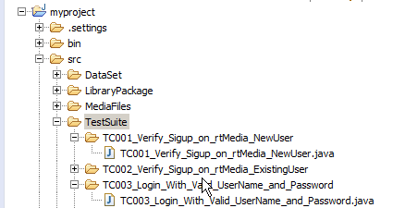

Test case sample code.

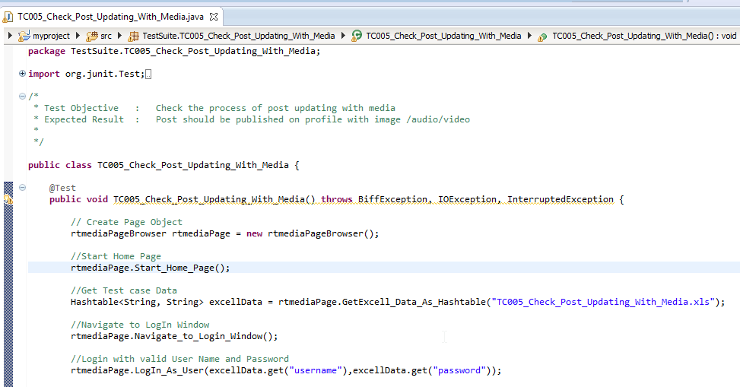

# Eclipse Setup

Download eclipse and add jar file to the build path.

Download and install JUnit.  
<https://github.com/junit-team/junit/wiki/Download-and-Install>

Create workspace on local drive and clone Automation framework code.

Clone URL: <https://github.com/devgujar/Assignment.git>

